Name: _______________________ ID: _______________________

**Analytical Chemistry II – Quiz (13th May, 2025)**

Explain the operational principle of electrospray ionization source used in mass spectrometry. Illustrate this explanation with a scheme of the device.

* Liquid sample is infused through a metal capillary.
* Electric voltage is applied to the capillary and a counter electrode (near the MS orifice).
* The liquid meniscus forms Taylor cone, and microdroplets detach from its apex.
* The microdroplets undergo desolvation (evaporation of solvent).
* Electric charge density on the surface of droplets increases.
* Because surface tension forces cannot balance electrostatic repulsion forces, the microdroplets undergo fission.
* Finally, all the solvent molecules evaporate leaving behind gaseous ions of analyte species.
* Multiply charged species are formed from large molecules.
* Ionization typically follows any of the following pathways:
  + protonation
  + deprotonation
  + formation of adducts

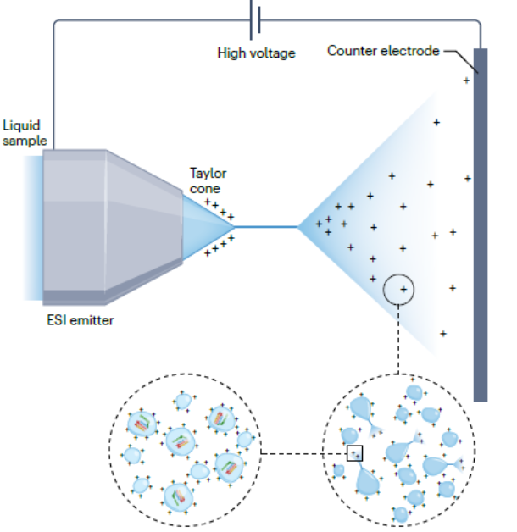  
Prabhu G. R. D., Williams E. R., Wilm M., Urban P. L. *Nat. Rev. Methods Primers* 2023, *3*, 23.